Warehouse Recommendations based on Qty Sold, In Stock, Expected Demand:

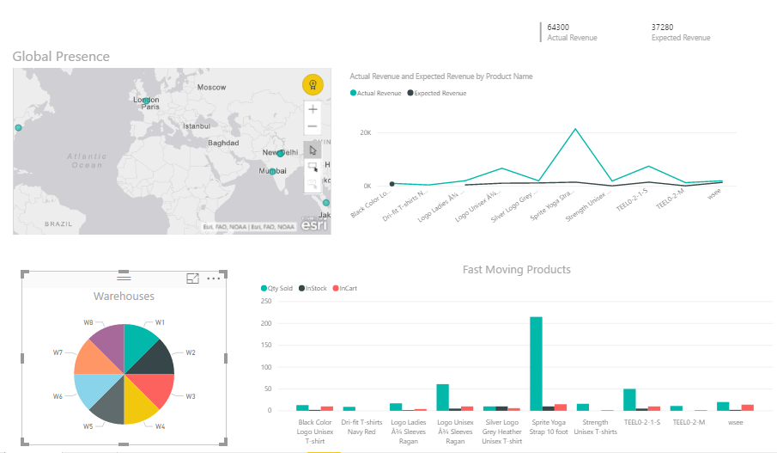

Warehouse Recommendations based on Products Catalogue:

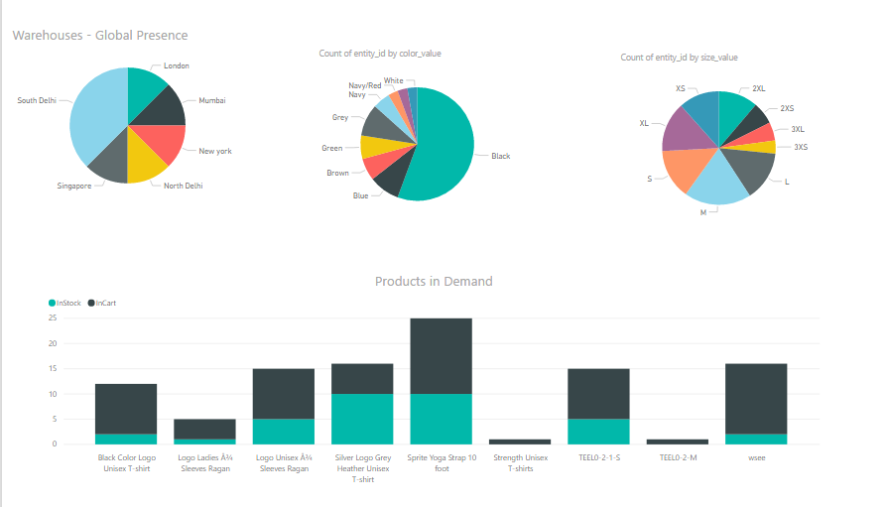

<https://app.powerbi.com/view?r=eyJrIjoiMmNiZDkxMTQtY2FkYy00ZDA3LWFlODQtYjI0ZmYwZDk3MmE2IiwidCI6ImZhOGY5NDk2LTRmZmEtNDI4MC04ZGFjLWFiZGEwZjBmNjVkMSIsImMiOjEwfQ%3D%3D>